Nu

Key Instant Recall Facts
Year 3 Autumn 1

I know number bonds for all numbers to 20.
By the end of this half term, children should know the following facts. The aim is for them to recall these facts instantly.
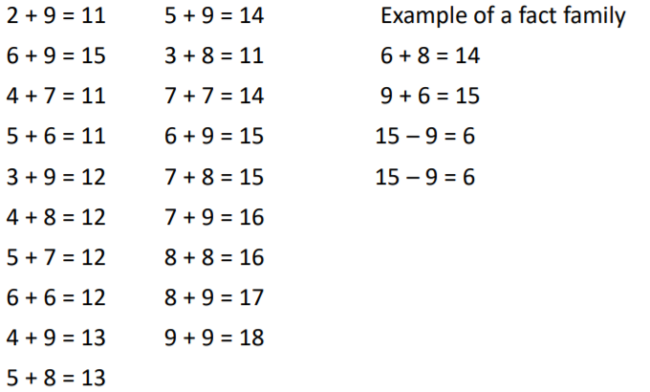
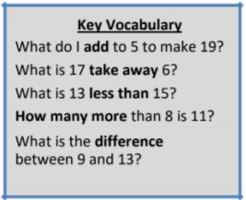

This list includes the most challenging facts but children will need to learn all number bonds for each number to 20 (e.g. 15 + 2 = 17). This includes related subtraction facts (e.g. 17 – 2 = 15).

Top Tips
The secret to success is practising little and often. Use time wisely. Can you practise these KIRFs while walking to school or during a car journey? You don’t need to practise them all at once: perhaps you could have a fact of the day. If you would like more ideas, please speak to your child’s teacher.
• Buy one get three free - If your child knows one fact (e.g. 8 + 5 = 13), can they tell you the other three facts in the same fact family?
• Use doubles and near doubles – If you know that 6 + 6 = 12, how can you work out 6 + 7? What about 5 + 7?

