Key Instant Recall Facts
Year 1 Summer 2

I can tell the time
By the end of this half term, children should know the following facts. The aim is for them to recall these facts instantly.

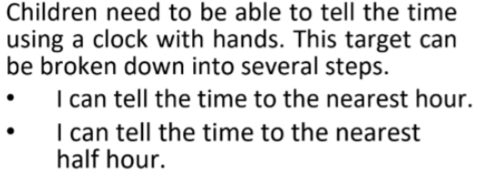

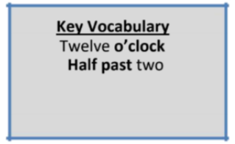

Top Tips
The secret to success is practising little and often. Use time wisely. Can you practise these KIRFs while walking to school or during a car journey? If you would like more ideas, please speak to your child’s teacher.
• Talk about time - Discuss what time things happen. When does your child wake up? What time do they eat breakfast? Make sure that you have an analogue clock visible in your house or that your child wears a watch with hands.
• Play “What’s the time Mr Wolf?”
• Read books about time

