Nu

Key Instant Recall Facts
Year R Autumn 2

I can say the numbers in order to 10.
Top Tips
• Miss out a number when counting to see if your child can spot your ‘mistake’.
• Use everyday opportunities to count whenever you can.
• Do alternate counting with your child.
• Say a number; your child says the next number.

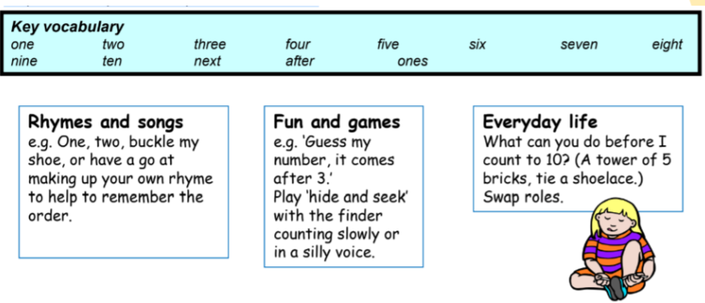

Building confidence in mathematics is crucial, so be pleased with their efforts and always encourage with praise. Make sure these practice sessions are enjoyable.

