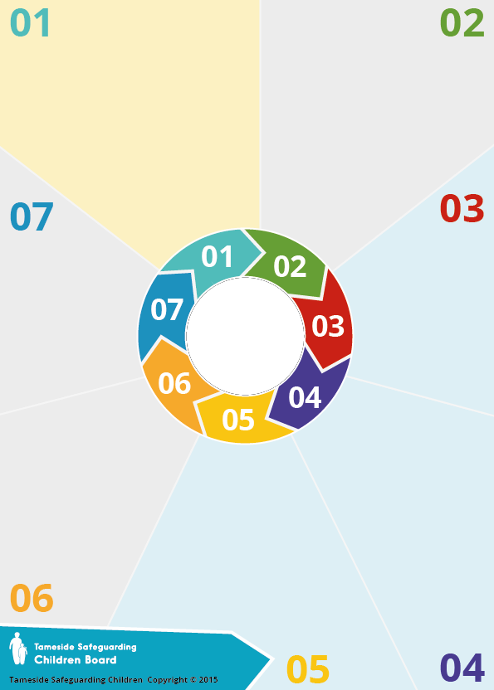
Background

All professionals now have the statutory duty to assist in
preventing terrorism (since 1st July 2015). The main aim is prevention and safeguarding.
The ‘Channel programme’ uses a multi-agency approach to protect people who are vulnerable by:
1. Identifying individuals at risk;
2. Assessing the nature and extent of that risk and
3. Developing an appropriate support plan for the .....individual.
There is no single indicator of when a person might .. move to adopt violence in support of extremist . ideas. The process of radicalisation is . ... ................................ different for everyone and can happen . .. quickly or slowly.

Why is matters

The risk of radicalisation is the product of a number of factors and identifying this risk requires that staff exercise their professional judgement, seeking further advice as necessary. Many agencies now have a single point of contact, often their safeguarding lead, who can assist. Channel staff are always happy to offer advice and support.



Prevent

What to do

Use the link below to refer a child in your school to Channel:

https://www.worcestershire.gov.uk/downloads/file/7583/prevention_of_extremism_and_radicalisation_-_referral_process

Questions to consider
Most extremists have identity issues and the need for a sense of ‘belonging’ – respect is key.

Some of the ideas for this are:

Mentoring, life skills, anger
management, cognitive behavioural
work, constrictive pursuits, education
and skills, careers advice and
assistance, family support, health
support, housing support,
substance misuse support

Advocating violent actions and means;
• Association with known extremists;
• Articulating support for violent extremist causes or leaders;
• Using extremist views to explain
personal disadvantage;
• Joining or seeking to join extremist
organisations;
• Seeking to recruit others to an
extremist ideology.

Information
Indicators of vulnerability can include:
• Identity Crisis/personal Crisis
• Personal Circumstances
• Unmet Aspirations-Perceptions . of injustice; feeling of failure
• Criminality
Potential indicators include:
• Use of inappropriate language;
• Possession of violent .. extremist literature

