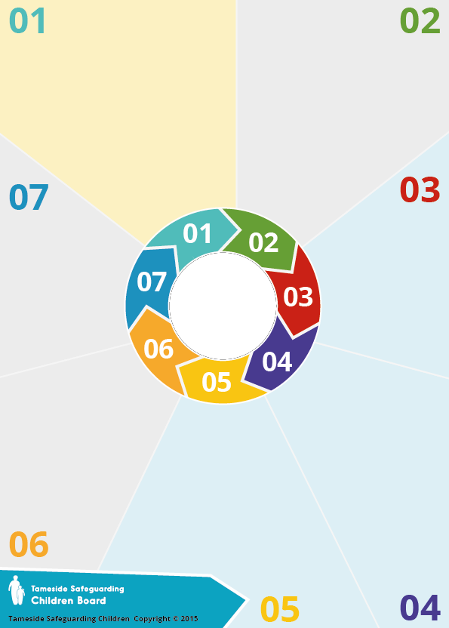
Background

The Mental Capacity Act 2005 (MCA) protects the right to self-determination for people whose capacity may be questioned and provides a legal process for professionals proposing making decisions for them. The decision-making provisions apply to people over 16, while some further provisions only apply to adults. It is essential that …….any person proposing to make a decision for a ,,,,,,,,,,,,..relevant person follows the Act.

The Five Principles

- A person must be assumed to have capacity unless it is established that they lack capacity.
- A person is not to be treated as unable to plan unless all practicable steps to help him to do so have been taken without success.
- A person is not to be treated as unable to decide merely because he makes an unwise decision.
- An act done, or decision made, under this Act for or on behalf of a person who lacks capacity must be done, or made, in his best interests.
- Before the act is done, or the decision is made, regard must be had to whether the purpose for which it is needed can be as effectively achieved in a way that is less restrictive of their rights ….. and freedom of ……….. action.


Useful Resources
Worcestershire's Mental Capacity Assessment and Best Interests Decision forms
Mental Capacity Act 2005 Code of Practice
This is highly readable and should be your first source of guidance.
Mental capacity case law library
A searchable resource of case law concerning how and when the MCA 2005 applies.
Assessing Mental Capacity.
This includes explanations of what information is relevant for certain decisions.
Making Best Interests Decisions. Guidance note by 39 Essex Chambers
Reference guide to consent for examination or treatment by Department of Health

Transitional Safeguarding. A strategic briefing by Research in Practice
The Liberty Protection Safeguards
Resources on the LPS, due in October 2020 and applying to 16 and 17 year-olds.
Capacity Stages

- A permanent or temporary impairment of or disturbance in the functioning of the mind or brain. (The 'diagnostic' test – not to be confused with having a formal diagnosis.)

2. Can they understand relevant . ….information for the decision, .retain it for long enough, use and weigh it to make a decision and communicate it? (The 'functional test'.)

3. Does one cause the other? The diagnostic issue may not cause the functional problem in all cases, so a link must be shown. (The 'causative nexus'.)

The Act also provides ………………………..protection from liability ……………………for those carrying out day-to ………………….-day care and treatment. This is …………………on the condition that the person …………………………………providing it:
• has taken reasonable steps to establish …………..that the young person lacks capacity.
• reasonably believes that the young person ………lacks capacity and that the act is in the young ….person’s best interests, and
• follows the Act’s principles.

Mental Capacity Act

