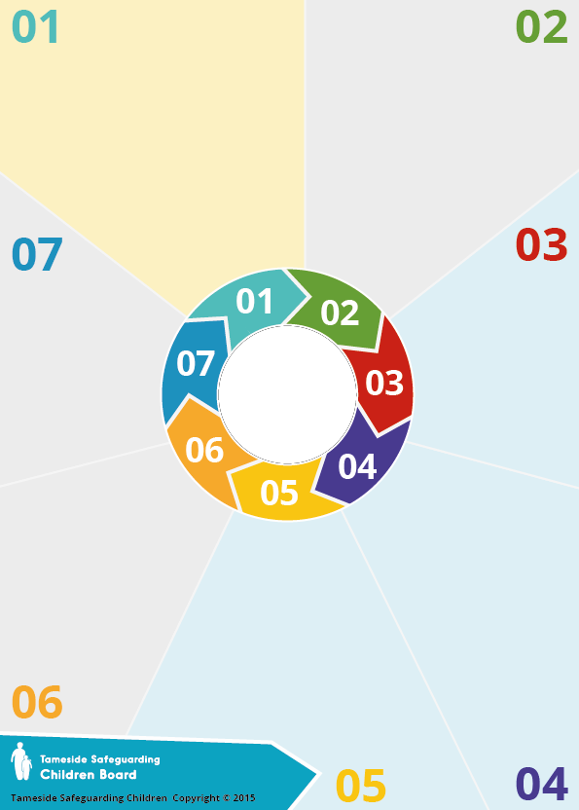
FGM comprises all procedures involving partial or total removal of the external female genitalia, or other injury to the female genital organs for non-medical reasons. FGM is prevalent in 30 countries concentrated in countries around the Atlantic coast to the Horn of Africa, in areas of the Middle East, and in some countries in Asia. It also takes place within parts of Western Europe and other developed countries, primarily among . .. ...immigrant and refugee communities where FGM is . ..........commonly believed to be a way of ensuring virginity ..................and chastity. The procedure may be carried out ...........................shortly after birth, during childhood or .................................adolescence, just before marriage or . during a woman’s first pregnancy. . The practice is not required by . .. any religion.

Background:

FGM is child abuse and a form of violence against women and girls. It has no health benefits but rather immediate and long-term consequences including severe pain and blood loss, shock, mental health problems, complications in childbirth, and/or death.
It is believed that FGM may happen to girls in the UK as well as overseas. Girls of school age subjected to FGM overseas are likely to be taken abroad (often to the family’s country of origin) at the start of the school holidays, particularly in the summer, in order for there to be sufficient time for them to recover before returning to school. FGM can be linked to Forced marriage and honour-based violence.
Why it matters:


Female Genital Mutilation
(FGM)

Key . .......... .....Guidance:

Home Office co-ordinates efforts
and offers outreach support to
local areas.

Multi-agency statutory guidance on FGM
(Home Office, July 2020)
Mandatory Reporting Guidance
Home Office 2020

What to do:

If you think a child or young person is at immediate risk of FGM you should contact the Family Front Door (FFD) – 01905 822 666 or in an emergency always call 999

Free Training:
Recognising and Preventing ... FGM (Home Office)

Questions:

- Have you undertaken any training ...round FGM
- Do you routinely consider FGM?
- Do you know what FGM is and
how to spot the signs?
- Do you know what to do/ ...where to refer if you suspect/ ...find.FGM?
- Do you know who your FGM ...
agency lead is?

The Law:
FGM is illegal in the UK. As amended by the Serious Crime Act 2015, the Female Genital Mutilation Act includes: an offence of failing to protect girls at risk of FGM; lifelong anonymity for victims; FGM protection orders; & mandatory reporting duty of known cases in under 18’s to police

Risk Indicators:
- Girl discusses special occasion/ceremony
to 'become a woman' /prepare for . .... marriage
. - Long holiday abroad/ going 'home'
. visiting family
. - Unexpected absence from . ............... school and is from a practicing . .................. community
-Relative/ cutter visiting from . ... ............. .abroad
. - A female relative being cut
. - Avoids exercise
- Spends longer in the . ......................................bathroom or toilet
- Difficulty walking,
standing or sitting

