

Key Instant Recall Facts
Year R Summer 2

I can count in 2s
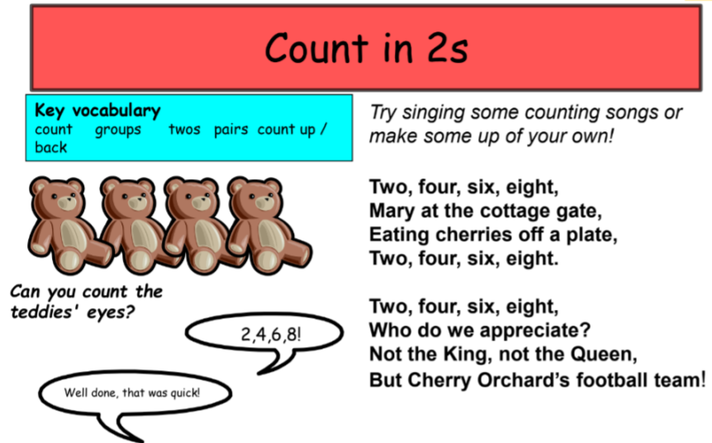

Building confidence in mathematics is crucial, so be pleased with their efforts and always encourage with praise. Make sure these practice sessions are enjoyable.

