
Nu

Key Instant Recall Facts
Year R Spring 1

I can partition the numbers to 5 into two groups.

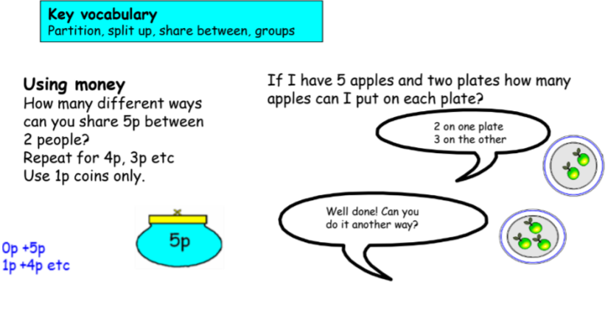

Building confidence in mathematics is crucial, so be pleased with their efforts and always encourage with praise. Make sure these practice sessions are enjoyable.

