
Nu

Key Instant Recall Facts
Year 5 Summer 2
I can recall metric conversions.
By the end of this half term, children should know the following facts. The aim is for them to recall these facts instantly.

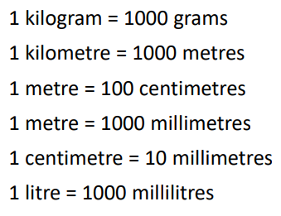

Top Tips
The secret to success is practising little and often. Use time wisely. Can you practise these KIRFs while walking to school or during a car journey? You don’t need to practise them all at once: perhaps you could have a fact of the day. If you would like more ideas, please speak to your child’s teacher.
• Look at the prefixes – Can your child work out the meanings of kilo-, centi- and milli-? What other words begin with these prefixes?
• Be practical – Do some baking and convert the measurements in the recipe. • How far? – Calculate some distances using unusual measurements. How tall is your child in mm? How far away is London in metres?

