
Nu

Key Instant Recall Facts
Year 5 Summer 1
I can find factor pairs of a number.
Children should now know all multiplication and division facts up to 12 × 12. When given a number in one of these times tables, they should be able to state a factor pair which multiply to make this number. Below are some examples:
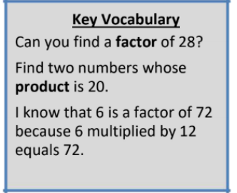
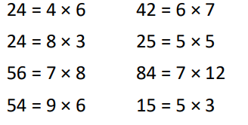

Top Tips
The secret to success is practising little and often. Use time wisely. Can you practise these KIRFs while walking to school or during a car journey? You don’t need to practise them all at once: perhaps you could have a fact of the day. If you would like more ideas, please speak to your child’s teacher.
• Think of the question – One player thinks of a times table question (e.g. 4 × 12) and states the answer. The other player has to guess the original question.
• Use memory tricks – For those hard-to-remember facts, www.multiplication.com has some strange picture stories to help children remember.

