
Nu

Key Instant Recall Facts
Year 5 Spring 2
I can recall square numbers up to 122 and their square roots.
By the end of this half term, children should know the following facts. The aim is for them to recall these facts instantly.
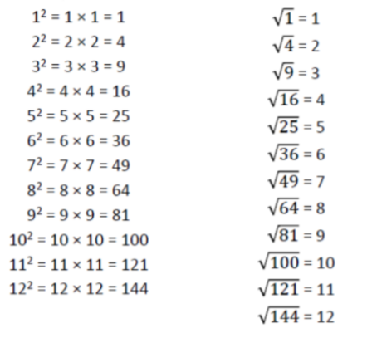

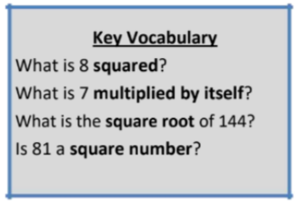

Top Tips
The secret to success is practising little and often. Use time wisely. Can you practise these KIRFs while walking to school or during a car journey? You don’t need to practise them all at once: perhaps you could have a fact family of the day. If you would like more ideas, please speak to your child’s teacher.
•Cycling Squares – At http://nrich.maths.org/1151 there is a challenge involving square numbers. Can you complete the challenge and then create your own examples?

