
Nu

Key Instant Recall Facts
Year 5 Spring 1
I can identify prime numbers up to 20.
By the end of this half term, children should know the following facts. The aim is for them to recall these facts instantly.

A prime number is a number with no factors other than itself and one.
The following numbers are prime numbers: 2, 3, 5, 7, 11, 13, 17, 19
A composite number is divisible by a number other than 1 or itself.
The following numbers are composite numbers: 4, 6, 8, 9, 10, 12, 14, 15, 16, 18, 20
Children should be able to explain how they know that a number is composite. E.g. 15 is composite because it is a multiple of 3 and 5
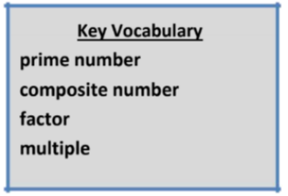

Top Tips
The secret to success is practising little and often. Use time wisely. Can you practise these KIRFs while walking to school or during a car journey? You don’t need to practise them all at once: perhaps you could have a fact family of the day. If you would like more ideas, please speak to your child’s teacher.
• It’s really important that your child uses mathematical vocabulary accurately. Choose a number between 2 and 20. How many correct statements can your child make about this number using the vocabulary above?
• Make a set of cards for the numbers from 2 to 20. How quickly can your child sort these into prime and composite numbers? How many even prime numbers can they find? How many odd composite numbers?

