
Nu

Key Instant Recall Facts
Year 5 Autumn 2
I can multiply and divide single-digit numbers by 10 and 100.
By the end of this half term, children should know the following facts. The aim is for them to recall these facts instantly.
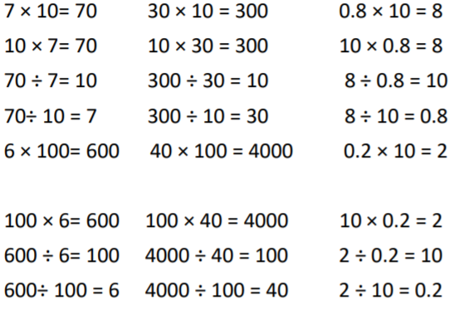

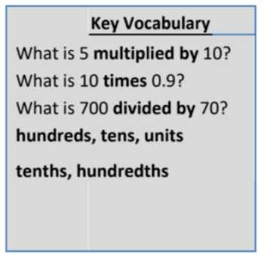

These are just examples of the facts for this term. Children should be able to answer these questions in any order, including missing number questions e.g. 10 × ⃝ = 5 or ⃝ ÷ 10 = 60.

Top Tips
The secret to success is practising little and often. Use time wisely. Can you practise these KIRFs while walking to school or during a car journey? You don’t need to practise them all at once: perhaps you could have a fact family of the day. If you would like more ideas, please speak to your child’s teacher.

