
Nu

Key Instant Recall Facts
Year 5 Autumn 1

I know decimal number bonds to 1 and 10.
By the end of this half term, children should know the following facts. The aim is for them to recall these facts instantly.
Some examples:
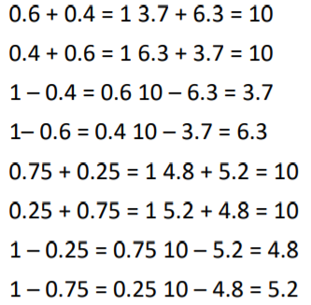
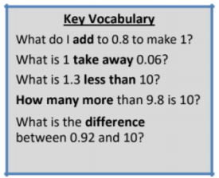

This list includes some examples of facts that children should know. They should be able to answer questions including missing number questions e.g. 0.49 + ⃝ = 10 or 7.2 + ⃝ = 10.

Top Tips The secret to success is practising little and often. Use time wisely. Can you practise these KIRFs while walking to school or during a car journey? You don’t need to practise them all at once: perhaps you could have a fact of the day. If you would like more ideas, please speak to your child’s teacher. • Buy one get three free - If your child knows one fact (e.g. 8 + 5 = 13), can they tell you the other three facts in the same fact family? • Use number bonds to 10 - How can number bonds to 10 help you work out number bonds to 100?

