
Nu

Key Instant Recall Facts
Year 4 Summer 2
I know the multiplication and division facts for all times tables up to 12 × 12.
By the end of this half term, children should know the following facts. The aim is for them to recall these facts instantly.

They should be able to answer these questions in any order, including missing number questions e.g. 7 × ⃝ = 28 or ⃝ ÷ 6 = 7.
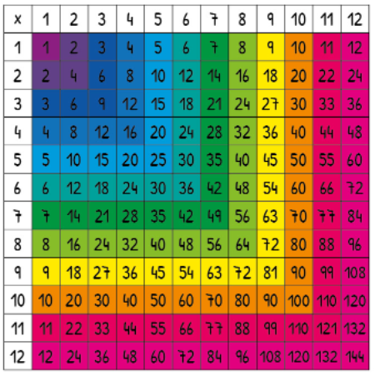
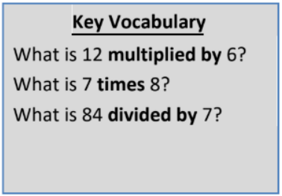

Top Tips
The secret to success is practising little and often. Use time wisely. Can you practise these KIRFs while walking to school or during a car journey? You don’t need to practise them all at once: perhaps you could have a fact family of the day. If you would like more ideas, please speak to your child’s teacher.
- Speed Challenge – Take two packs of playing cards and remove the kings. Turn over two cards and ask your child to multiply the numbers together (Ace = 1, Jack = 11, Queen = 12). How many questions can they answer correctly in 2 minutes? Practise regularly and see if they can beat their high score
• Use memory tricks – For those hard-to-remember facts, www.multiplication.com has some strange picture stories to help children remember.

