
Nu

Key Instant Recall Facts
Year 4 Summer 1
I can recognise decimal equivalents of fractions.
By the end of this half term, children should know the following facts. The aim is for them to recall these facts instantly.

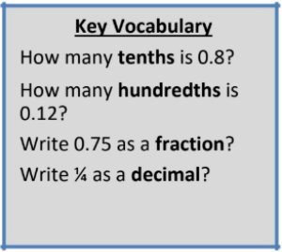
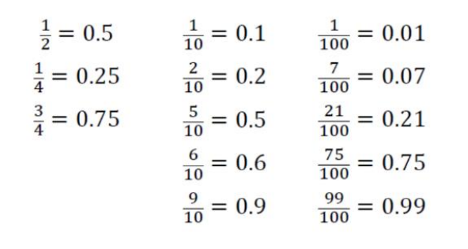

Children should be able to convert between decimals and fractions for ½, ¼, ¾ and any number of tenths and hundredths.

Top Tips
The secret to success is practising little and often. Use time wisely. Can you practise these KIRFs while walking to school or during a car journey? You don’t need to practise them all at once: perhaps you could have a fact family of the day. If you would like more ideas, please speak to your child’s teacher.
• Play games - Make some cards with pairs of equivalent fractions and decimals. Use these to play the memory game or snap.
• Or make your own dominoes with fractions on one side and decimals on the other.

