
Nu

Key Instant Recall Facts
Year 4 Spring 2
I know the multiplication and division facts for the 7 times table.
By the end of this half term, children should know the following facts. The aim is for them to recall these facts instantly.
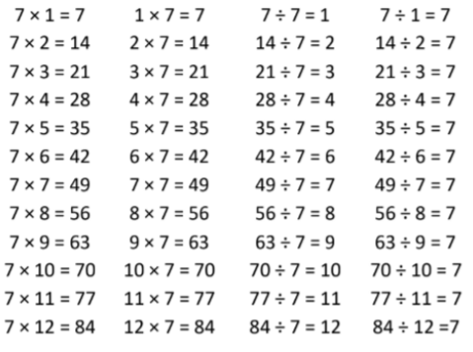
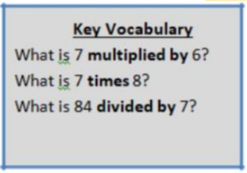

They should be able to answer these questions in any order, including missing number questions e.g. 7 × ⃝ = 28 or ⃝ ÷ 6 = 7.

Top Tips
The secret to success is practising little and often. Use time wisely. Can you practise these KIRFs while walking to school or during a car journey? You don’t need to practise them all at once: perhaps you could have a fact family of the day. If you would like more ideas, please speak to your child’s teacher.
• Order of difficulty – Ask your child to order these facts from the easiest to the most challenging. Can they explain why some facts are easier to remember? Then focus on practising the most challenging facts.
• Use memory tricks – For those hard-to-remember facts, www.multiplication.com has some strange picture stories to help children remember.

