
Nu

Key Instant Recall Facts
Year 4 Spring 1
I know the multiplication and division facts for the 9 and 11 times table.
By the end of this half term, children should know the following facts. The aim is for them to recall these facts instantly.
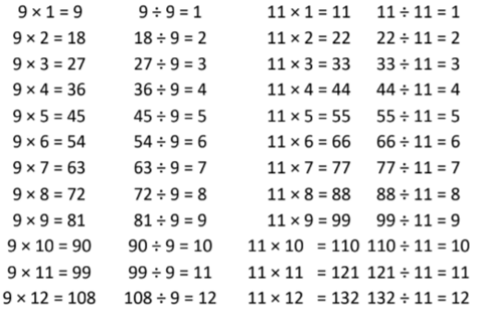
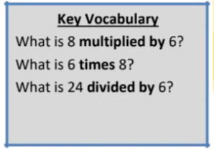

They should be able to answer these questions in any order, including missing number questions e.g. 9 × ⃝ = 54 or ⃝ ÷ 9 = 11.

Top Tips
The secret to success is practising little and often. Use time wisely. Can you practise these KIRFs while walking to school or during a car journey? You don’t need to practise them all at once: perhaps you could have a fact family of the day. If you would like more ideas, please speak to your child’s teacher.
Look for patterns – These times tables are full of patterns for your child to find. How many can they spot?
• Use your ten times table – Multiply a number by 10 and subtract the original number (e.g. 7 × 10 – 7 = 70 – 7 = 63). What do you notice? What happens if you add your original number instead? (e.g. 7 × 10 + 7 = 70 + 7 = 77)
• What do you already know? – Your child will already know many of these facts from the 2, 3, 4, 5, 6, 8 and 10 times tables. It might be worth practising these again.

