
Nu

Key Instant Recall Facts
Year 4 Autumn 2
I know the multiplication and division facts for the 6 times table.
By the end of this half term, children should know the following facts. The aim is for them to recall these facts instantly.
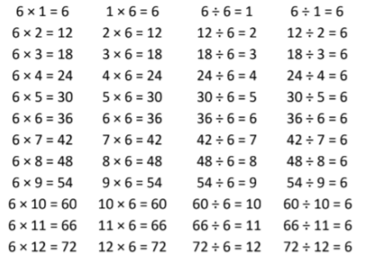
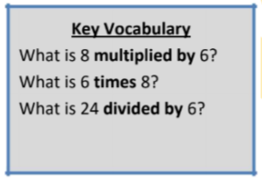

They should be able to answer these questions in any order, including missing number questions e.g. 6 × ⃝ = 72 or ⃝ ÷ 6 = 7.

Top Tips
The secret to success is practising little and often. Use time wisely. Can you practise these KIRFs while walking to school or during a car journey? You don’t need to practise them all at once: perhaps you could have a fact family of the day. If you would like more ideas, please speak to your child’s teacher.
• Songs and Chants – You can buy Times Tables CDs or find multiplication songs and chants online. If your child creates their own song, this can make the times tables even more memorable.
• Double your threes – Multiplying a number by 6 is the same as multiplying by 3 and then doubling the answer. 7 × 3 = 21 and double 21 is 42, so 7 × 6 = 42. • Buy one get three free – If your child knows one fact (e.g. 3 × 6 = 18), can they tell you the other three facts in the same fact family? Warning! – When creating fact families, children sometimes get confused by the order of the numbers in the division number sentence. It is tempting to say that the biggest number goes first, but it is more helpful to say that the answer to the multiplication goes first, as this will help your child more in later years when they study fractions, decimals and algebra. E.g. 6 × 12 = 72. The answer to the multiplication is 72, so 72 ÷ 6 = 12 and 72 ÷ 12 = 6

