
Nu

Key Instant Recall Facts
Year 4 Autumn 1

I know number bonds to 100
By the end of this half term, children should know the following facts. The aim is for them to recall these facts instantly.

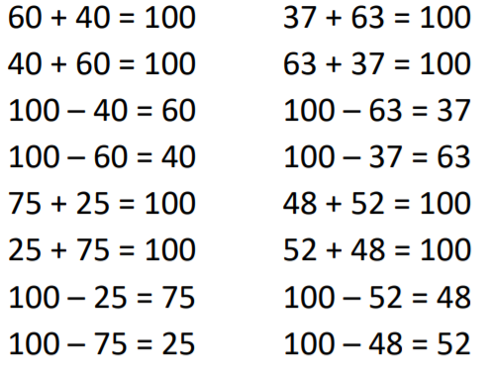
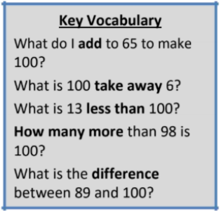
Some Examples:

Top Tips
The secret to success is practising little and often. Use time wisely. Can you practise these KIRFs while walking to school or during a car journey? You don’t need to practise them all at once: perhaps you could have a fact of the day. If you would like more ideas, please speak to your child’s teacher.
• Buy one get three free - If your child knows one fact (e.g. 8 + 5 = 13), can they tell you the other three facts in the same fact family?
• Use number bonds to 10 - How can number bonds to 10 help you work out number bonds to 100?

