

Key Instant Recall Facts
Year 3 Summer 1

I can tell the time.
By the end of this half term, children should know the following facts. The aim is for them to recall these facts instantly.

Children need to be able to tell the time using a clock with hands. This can be broken down into several steps.
- I can tell the time to the nearest hour.
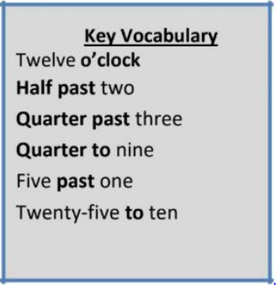
- I can tell the time to the nearest half hour.
- I can tell the time to the nearest quarter hour.
- I can tell the time to the nearest five minutes.
- I can tell the time to the nearest minute.

Top Tips
The secret to success is practising little and often. Use time wisely. If you would like more ideas, please speak to your child’s teacher.
• Talk about time - Discuss what time things happen. When does your child wake up? What time do they eat breakfast? Make sure that you have an analogue clock visible in your house or that your child wears a watch with hands. Once your child is confident telling the time, see if you can find more challenging clocks e.g. with Roman numerals or no numbers marked.
• Ask your child the time regularly – You could also give your child some responsibility for watching the clock : “The cakes need to come out of the oven at twenty-two minutes past four exactly.” “We need to leave the house at twenty-five to nine.”

