

Key Instant Recall Facts
Year 3 Summer 2

I can recall facts about durations of time.
By the end of this half term, children should know the following facts. The aim is for them to recall these facts instantly.

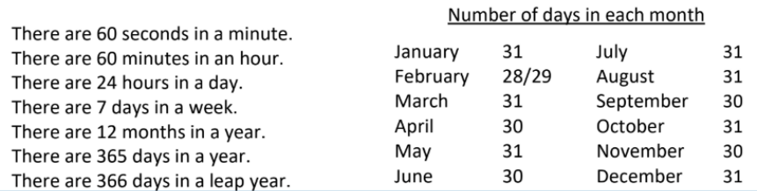

Top Tips
The secret to success is practising little and often. Use time wisely. If you would like more ideas, please speak to your child’s teacher.
• Use rhymes and memory games– The rhyme, Thirty days hath September, can help children remember which months have 30 days. There are poems describing the months of the year in order.
• Use calendars – If you have a calendar for the new year, your child could be responsible for recording the birthdays of friends and family members in it. Your child could even make their own calendar.
• How long is a minute? – Ask your child to sit with their eyes closed for exactly one minute while you time them. Can they guess the length of a minute? Carry out different activities for one minute. How many times can they jump in sixty seconds?

