

Key Instant Recall Facts
Year 3 Spring 1

I know the multiplication and division facts for the 4 times table.
By the end of this half term, children should know the following facts. The aim is for them to recall these facts instantly.

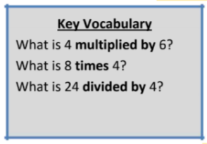
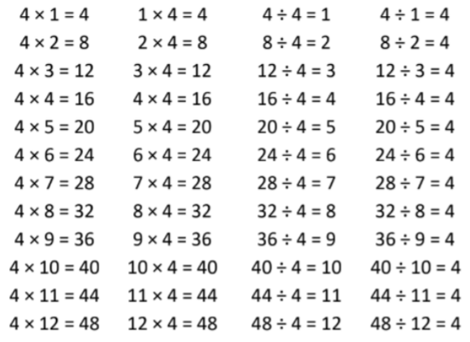

They should be able to answer these questions in any order, including missing number questions e.g. 4 × ⃝ = 16 or ⃝ ÷ 4 = 7.

Top Tips
The secret to success is practising little and often. Use time wisely. Can you practise these KIRFs while walking to school or during a car journey? You don’t need to practise them all at once: perhaps you could have a fact family of the day. If you would like more ideas, please speak to your child’s teacher.
• What do you already know? – Your child will already know many of these facts from the 2, 3, 5 and 10 times tables.
• Double and double again – Multiplying a number by 4 is the same as doubling and doubling again. Double 6 is 12 and double 12 is 24, so 6 × 4 = 24.
• Buy one get three free – If your child knows one fact (e.g. 12 × 4 = 48), can they tell you the other three facts in the same fact family?

