
Nu

Key Instant Recall Facts
Year 2 Summer 2

I can tell the time
By the end of this half term, children should know the following facts. The aim is for them to recall these facts instantly.
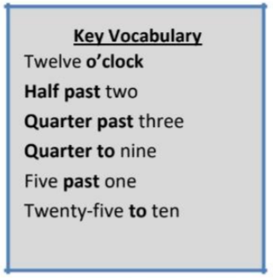
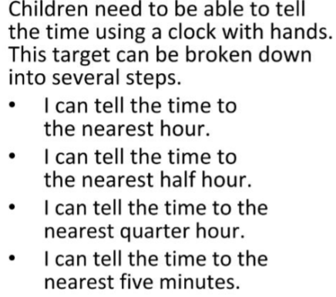

Children should be able to answer questions in any order, including missing number questions e.g. 5 × ⃝ = 40 or ⃝ ÷ 5 = 9.
Top Tips
The secret to success is practising little and often. Use time wisely. Can you practise these KIRFs while walking to school or during a car journey? You don’t need to practise them all at once: perhaps you could have a fact of the day. If you would like more ideas, please speak to your child’s teacher.
Talk about time - Discuss what time things happen. When does your child wake up? What time do they eat breakfast? Make sure that you have an analogue clock visible in your house or that your child wears a watch with hands.
• Ask your child the time regularly – You could also give your child some responsibility for watching the clock: “The cakes need to come out of the oven at quarter past four.” “We need to leave the house at half past eight.”

