
Nu

Key Instant Recall Facts
Year 2 Spring 2

I know the multiplication and division facts for the 10 times table
By the end of this half term, children should know the following facts. The aim is for them to recall these facts instantly.
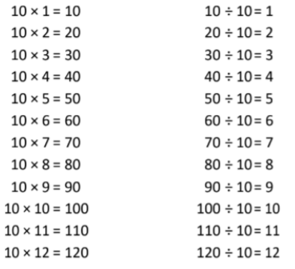
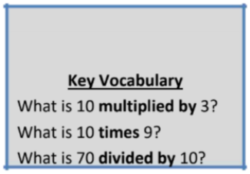

Children should be able to answer questions in any order, including missing number questions e.g. 10 × ⃝ = 80 or ⃝ ÷ 10 = 6.
Top Tips
The secret to success is practising little and often. Use time wisely. Can you practise these KIRFs while walking to school or during a car journey? You don’t need to practise them all at once: perhaps you could have a fact of the day. If you would like more ideas, please speak to your child’s teacher.
• Pronunciation – Make sure that your child is pronouncing the numbers correctly and not getting confused between thirteen and thirty.
• Songs and Chants – You can buy Times Tables CDs or find multiplication songs and chants online. If your child creates their own song, this can make the times tables even more memorable.
• Test the Parent – Your child can make up their own tricky division questions for you e.g. What is 70 divided by 7? They need to be able to multiply to create these questions.
• Apply these facts to real life situations – How many toes are in your house? What other multiplication and division questions can your child make up?

