
Nu

Key Instant Recall Facts
Year 2 Spring 1

I know doubles and halves of numbers to 20.
By the end of this half term, children should know the following facts. The aim is for them to recall these facts instantly.

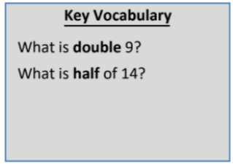
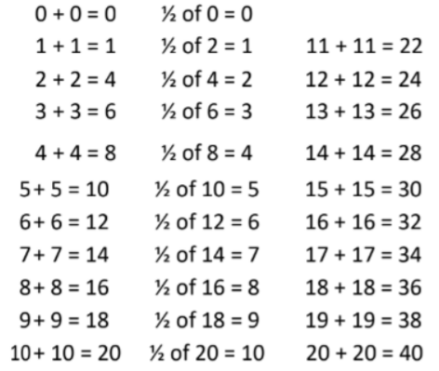

Top Tips
The secret to success is practising little and often. Use time wisely. Can you practise these KIRFs while walking to school or during a car journey? You don’t need to practise them all at once: perhaps you could have a fact of the day. If you would like more ideas, please speak to your child’s teacher.
• Use what you already know – encourage your child to find the connection between the 2 times table and double facts.
• Ping Pong – In this game, the parent says, “Ping,” and the child replies, “Pong.” Then the parent says a number and the child doubles it. For a harder version, the adult can say, “Pong.” The child replies, “Ping,” and then halves the next number given.

