
Nu

Key Instant Recall Facts
Year 2 Autumn 2

I know the multiplication and division facts for the 2 times table.
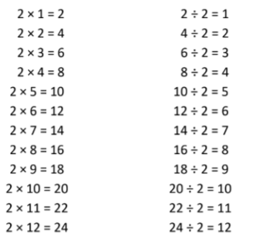
By the end of this half term, children should know the following facts. The aim is for them to recall these facts instantly.

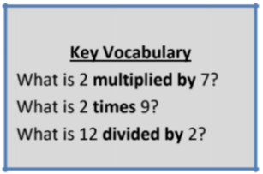

They should be able to answer these questions in any order, including missing number questions e.g. 2 × ⃝ = 8 or ⃝ ÷ 2 = 6.

Top Tips
The secret to success is practising little and often. Use time wisely. Can you practise these KIRFs while walking to school or during a car journey? You don’t need to practise them all at once: perhaps you could have a fact of the day. If you would like more ideas, please speak to your child’s teacher.
• Songs and Chants – You can buy Times Tables CDs or find multiplication songs and chants online. If your child creates their own song, this can make the times tables even more memorable.
• Use what you already know – If your child knows that 2 × 5 = 10, they can use this fact to work out that 2 × 6 = 12.
• Test the Parent – Your child can make up their own tricky division questions for you e.g. What is 18 divided by 2? They need to be able to multiply to create these questions.
• Use memory tricks – For those hard-to-remember facts, www.multiplication.com has some strange picture stories to help children remember.

