
Nu

Key Instant Recall Facts
Year 2 Autumn 1

I know number bonds to 20.
By the end of this half term, children should know the following facts. The aim is for them to recall these facts instantly.
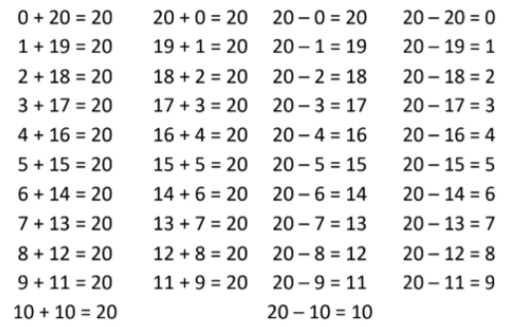
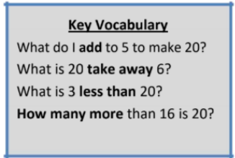

Top Tips
The secret to success is practising little and often. Use time wisely. Can you practise these KIRFs while walking to school or during a car journey? You don’t need to practise them all at once: perhaps you could have a fact of the day. If you would like more ideas, please speak to your child’s teacher.

• Use what you already know – Use number bonds to 10 (e.g. 7 + 3 = 10) to work out related number bonds to 20 (e.g. 17 + 3 = 20).
• Use practical resources – Make collections of 20 objects. Ask questions such as, “How many more conkers would I need to make 20?”

