

Key Instant Recall Facts
Year 1 Summer 1

I know doubles and halves of number to 10
By the end of this half term, children should know the following facts. The aim is for them to recall these facts instantly.
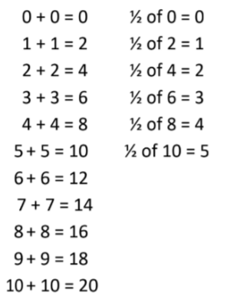

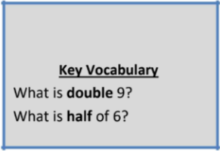

Top Tips
The secret to success is practising little and often. Use time wisely. Can you practise these KIRFs while walking to school or during a car journey? If you would like more ideas, please speak to your child’s teacher.
Ping Pong – In this game, the parent says, “Ping,” and the child replies, “Pong.” Then the parent says a number and the child doubles it. For a harder version, the adult can say, “Pong.” The child replies, “Ping,” and then halves the next number given.

