
Nu

Key Instant Recall Facts
Year 1 Spring 1

I know number bonds to 10
By the end of this half term, children should know the following facts. The aim is for them to recall these facts instantly.
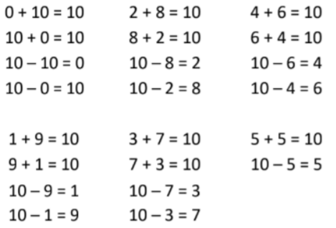

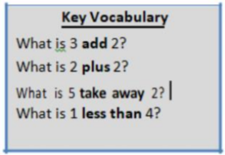

They should be able to answer these questions in any order, including missing number questions e.g. 6 + ⃝ = 10 or 10 – ⃝ = 3.

Top Tips

The secret to success is practising little and often. Use time wisely. Can you practise these KIRFs while walking to school or during a car journey? If you would like more ideas, please speak to your child’s teacher.

