
Nu

Key Instant Recall Facts
Year 1 Autumn 1

I can count to 50 and beyond.
By the end of this half term, children should know the following facts. The aim is for them to recall these facts instantly.
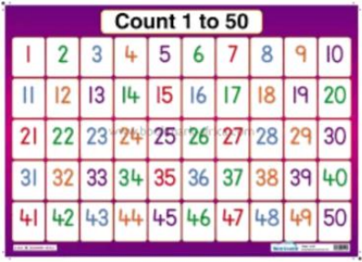
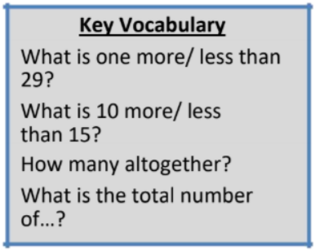

By the end of the half term children should be confident in counting up to 50, and some children will be able to count beyond this. As a challenge children may also wish to learn to count back from 50 too!

Top Tips

The secret to success is practising little and often. Use time wisely. Can you practise these KIRFs while walking to school or during a car journey? If you would like more ideas, please speak to your child’s teacher. • Use practical resources – Count the number of peas on a plate, lampposts in the street or pages in a book.

